Phylum Anthophyta: the flowering plant
- What do you notice about the sepals and the petals of this flower?
The sepals and the petals of the flower were brightly colored additionally they looked the same. Furthermore, the flower does not have green sepals like most flowers. The flower had three petals and three modified sepals. The petals are overlapped the sepals.
- How many stamens and carpals are there?
The flower had both the female and male reproductive organs. The flower had one female reproductive organ (pistil/carpel) which is surrounded by the stamens and consisted of the stigma, style and ovary. The stamens were 6 and they surrounded the pistil. The stamens had large black anthers that contained the pollen and the filaments holding the anthers.
Flower anatomy and pollination
- There are 4 of what structures inside the anther?
The anther is an inflamed saclike structure at the tip of the filament and part of the stamen. The anthers consist of four microsporangia nourished by a layer of tapetum cells. At the middle of each microsporangium are large numbers of mother pollen cells. These mother pollen cells undergo meiosis to form pollen grains.
- What are the cells called the comprise this structure and what are their ploidy?
The microsporangia consist of diploid sporocyte cells. In addition theWhich does your flower produce in greater numbers: ovules or pollen grains?
The flower produces numerous pollen grains in the microsporangia
- What type of cell division do these cells undergo?
Each of the sporocytes in the microsporangia undergoes mieosis to form four haploid cells with each containing one set of chromosomes. The sporocyte nucleus in the ovules divides by meiosis to form four haploid cell with a one set of chromosome separated by walls forming the megaspore cells. However, three of the cells formed degenerate.
- What substance does the spore/pollen grain become coated in?
The pollen grains are coated by the sporopollenin. Sporopollenin is a tough resistant biopolymer that coats the outer walls of pollen grains it helps them remain preserved. Additionally, sporopollenin is resistant to degradation by enzymes.
- What structures comprise the ovules?
The ovule is a component of the pistil contained in the ovaries and develops into seeds after fertilization. The ovule is made up of the megasporocyte, nucleus, integuments that form two layers that surround the mega sporangia and a small opening that is not covered by the integuments known as the micropyle.
- What is the ploidy of the sporocyte cell within the megasporangia and what type of cell division does it undergo?
The sporocyte cell within megasporangia is a diploid cell. The sporocyte divides by meiosis to form four haploid cells. The haploid cells have one set of chromosome. The four cells are known as megaspore cells, in most plant they are separated by a wall.
- What are the 7 cells comprising of the female gamete?
Three of the megaspores formed degenerate and the remaining megaspore enlarges and the nucleus divides 3 to form 8 nuclei. Two of the nuclei migrate into the middle of the nuclei to form the polar nuclei hence seven cells are formed. These seven cells comprising of the female gametophyte or the embryo sac include the egg cell and two synergid cells at the micropyle end, in the middle there is the central cell comprised of the two polar nuclei and lastly three antipodal cells.
- What three cells travel down the pollen tube during fertilization?
After pollination, a pollen tube develops that transports two sperm cell and the pollen tube cell to the ovule. The generative cell divides to form the two sperm cells. Since the sperm cells of seed plants have lost their motility they are transported to the megasporangia through a vegetative pollen tube in order to initiate fertilization.
- Where does the pollen tube penetrate the megesporangium?
The pollen tube penetrates through the micropyle to the megasporangium and grows into the synergid cells and then releasing the sperm cells.
- What happens to the 2 sperm cells inside the megasporangium and what do they become during double fertilization?
Upon penetration of the pollen tube into the megasporangium, the sperm cells are released. One of the sperm cell fertilizes the egg cell forming a diploid zygote. Whereas the second sperm cell fused with the two polar nuclei to produce a triploid cell that later develops into a primary endosperm cell hence the double fertilization of the angiosperms.
- Explain the difference between pollination and fertilization?
Pollination is the transfer of pollen grains from the anther to the stigma of the same flower or a different whereas fertilization is the fusion of the male gamete with the female gamete. There are two types of pollination self-pollination and cross-pollination.
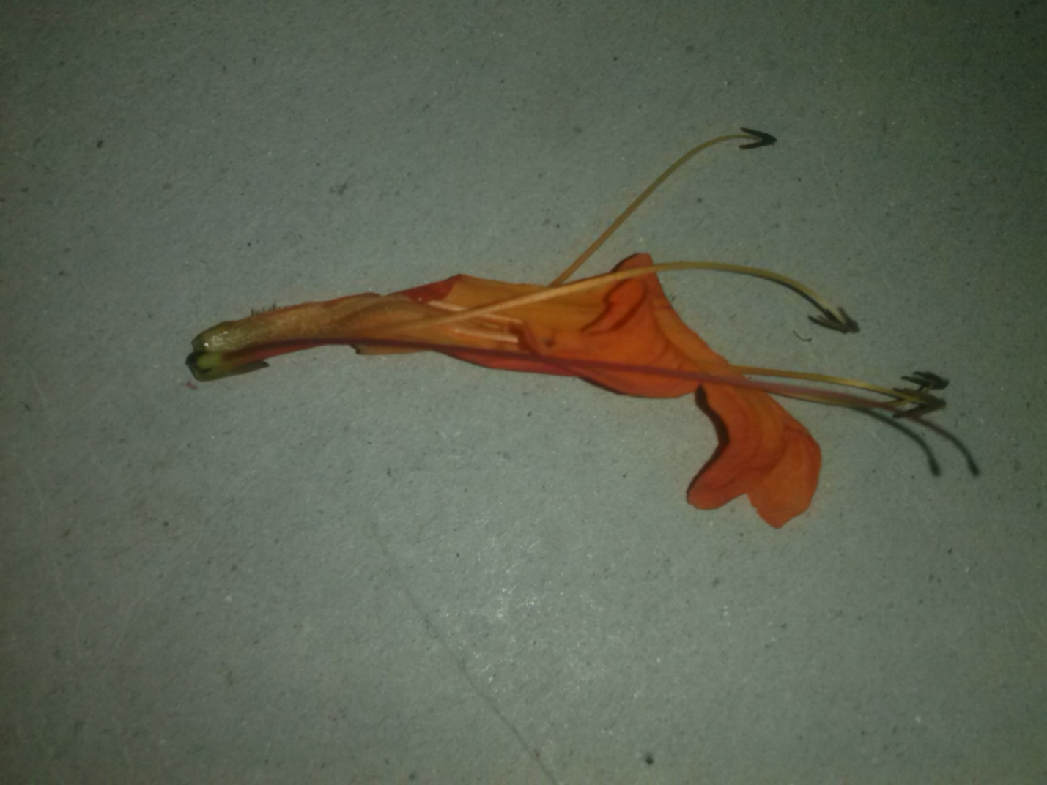
The flower has four stamens with long yellow filaments and dark anthers. The style is slender and pink and a dark rounded stigma.
The flower has one pistil, and five petals

Fruit name | Fruit type | Dispersal method
coconut | One-seeded drupe | Water-the seeds are light to float on water
Maple fruit | Dry fruit | Wind dispersal as they are winged to offer a longer time for dispersal
Red mulberry | Multiple fruit | Animals mode o dispersal- they have small tough seeds that are dispersed after passing through the animals digestive system.
cocklebur | Dry fruit | Adhesion to fur due to presence of the hooks
White oak | Dry fruit | Animals-the squirrels stock the nut which eventually germinate if not consumed

Coniferophyta
- What is the ploidy of the microsporocyte?
The microsporocytes are within a layer of cell called tapetum. The nucleus of each microsporocyte is diploid containing two sets of chromosomes one from each parent.
- What are the component of the pollen grain?
The pollen grain consists of an external wall surrounding the male gametophyte. The dome shaped structure contains the immature male gametophyte consist of spore cell with haploid nuclei. Three mitotic cell divisions takes place to form one generative cell, one tube cell and two prothallial cells.
- What disperses the pollen grain?
After deposition of sporopollenin the microsporangia open up releasing the pollen grains which are the dispersed by air currents.
- What structure comprises of the ovuliferous scales?
The ovuliferous scales are spirally arranged and are contained in the ovulate cones. These ovuliferous scale consists of tiny bracts. Two ovules surrounded by an integument, micropyle and a megasporangium and megasporocytes.
- What is the ploidy of the megasporocyte cell?
The megasporangium contains a diploid megasporocyte.
- To the right is a SEM of a pollen grain from a conifer with its two inflated wings. What would be the adaptive advantage of being with these wings?
Conifers seed are dispersed by wind therefore having the wings enables the seeds to be blown away as far as possible by the mind to the female reproductive organs.
- In many conifers the female ovulate cones are located towards the top of the tree above the male pollen cones. Why would this be? What would be genetic advantage?
Conifers depend on wind for pollen dispersal. However, the female cones are above the male cone to reduce the chances of self-pollination.
- Why do you think female cones are so tough and often covered in large spikes?
When the seeds mature the female cone scales becomes brown, dry and woody to create enough space for the seeds to fall out.
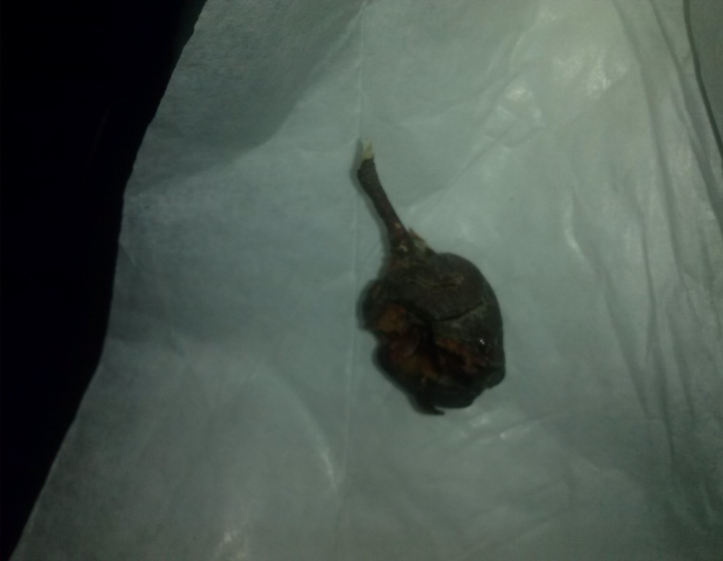
The cone lacked the micropyle but had the integument and the bracts.
Tree rings
- What is dendrochronology?
Dendrochronology is also known as tree ring dating is the science that utilizes tree rings to determine their exact year of formation and is based on the phenomenon that tress generally grow.
- How can we detect drought by looking at the tree ring?
Tree growth is affected by various aspect such for instance sunshine duration, humidity and temperatures. Trees contain nature’s most precise evidence of the past. Appearance of the rings record evidence of drought, floods or even earthquakes. In the case of wet and cool period the trees will produce wider rings than during the hot and dry period.
- Why do you think trees in the tropics do not show ring?
Tropic rainforests do not experience extreme winters and summer hence the trees do not have tree rings.
- What might have happened to the Roanoke colony in the 16 the century in North Carolina?
It is also known as the lost colony; the weather could have been extremely which could have led to almost entire becoming extinct.
Its iv very fascinating how the use of trees brings about a lovely music, the variation of the different trees brings about a different tune. Hence, despite use of tree rings to determine the age of trees they can be used to create lovely melody.

